**PHYSICS Stage 3**

Student Name: ______________________________

Teacher Name: ________________________________

**Time allowed for this paper**

Reading time before commencing work: ten minutes Working time for paper: three hours

**Materials required/recommended for this paper**

***To be provided by the supervisor***

This Question/Answer Booklet Formulae and Constants Sheet

***To be provided by the candidate***

Standard items: pens, pencils, eraser, correction fluid/tape, ruler, highlighters

Special items: non-programmable calculators satisfying the conditions set by the Curriculum Council for this course, drawing templates, drawing compass and a protractor

**Important note to candidates**

No other items may be taken into the examination room. It is **your** responsibility to ensure that you do not have any unauthorised notes or other items of a non-personal nature in the examination room. If you have any unauthorised material with you, hand it to the supervisor **before** reading any further.

**Structure of this paper**

|  |  |  |  |  |  |
| --- | --- | --- | --- | --- | --- |
| Section | Number of questions available | Number of questions to be answered | Suggested working time (minutes) | Marks available | Percentage of exam |
| Section One: Short answer | 13 | 13 | 50 | 54 | 30 |
| Section Two: Extended answer | 6 | 6 | 90 | 90 | 50 |
| Section Three: Comprehension and data analysis | 2 | 2 | 40 | 36 | 20 |
|  |  |  |  | **Total** | 100 |

**Instructions to candidates**

1. The rules for the conduct of Western Australian external examinations are detailed in the *Year 12 Information Handbook 2011.* Sitting this examination implies that you agree to abide by these rules.
2. Write answers in this Question/Answer Booklet.
3. You must be careful to confine your responses to the specific questions asked and to follow any instructions that are specific to a particular question.
4. Working or reasoning should be clearly shown when calculating or estimating answers.
5. Spare pages are included at the end of this booklet. They can be used for planning your responses and/or as additional space if required to continue an answer.

* Planning: If you use the spare pages for planning, indicate this clearly at the top of the page.
* Continuing an answer: If you need to use the space to continue an answer, indicate in the original answer space where the answer is continued, i.e. give the page number. Fill in the number of the question(s) that you are continuing to answer at the top of the page.

**STAGE 3 PHYSICS**

**Section One: Short answer 30% (54 Marks)**

This section has **13** questions. Attempt **all** questions.

Suggested working time: 50 minutes.

**Question 1 (4 marks)**

1. State the ‘***Law of Conservation of Energy’***.
2. Explain the following observation in terms of the ‘***Law of Conservation of Energy’***.

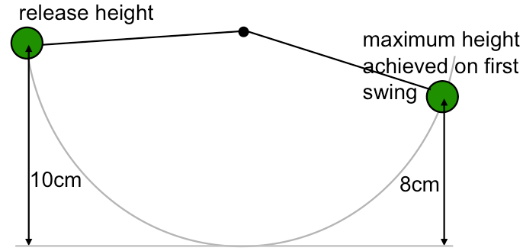

**Question 2 (4 marks)**

1. Select which of the following situations will allow the cyclist to corner at the highest speed.
2. Explain your selection. (Include vectors added to the diagrams to assist your explanation.)

|  |  |
| --- | --- |
| Situation 1: Horizontal  road surface | Situation 2: Inclined  road surface |

**Question 3 (4 marks)**

Two charged particles, **R** and **S,** enter a uniform magnetic field travelling with the **same velocity**.

**R** has a mass of **3m kg** and a charge of **-q C**, and **S** has a mass of **m kg** and a charge of **+3q C**.

Shown in the diagram below is the path that particle **R** follows. Draw the path that particle **S** would follow as it moves in the magnetic field.

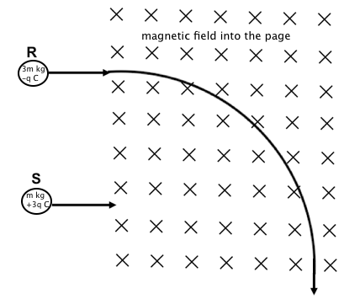

**Question 4 (4 marks)**

**Estimate** the force of gravitational attraction that exists between yourself and a calculator sitting on your desk.

**Question 5 (4 marks)**

|  |  |
| --- | --- |
| A student has two screwdrivers as shown in the diagram at the right.  The diameter of screwdriver 1 is 2.5 times the diameter of screwdriver 2. ie **D = 2.5d**  The length of screwdriver 2 is 2.5 times the length of screwdriver 1. ie **L = 2.5l**  (a) Which of the screwdrivers would unscrew a tight screw with the least force, and why? |  |

|  |  |
| --- | --- |
| (b) Which of the two screwdrivers would be best to use when levering the lid off a paint can, and why? |  |

**Question 6 (6 marks)**

John is a keen golfer, and student of physics. He thought that he could improve his game by using his knowledge of projectile motion. He calculated the launch angle and velocity to achieve his required range. Unfortunately he neglected to include the effect of air resistance and his golf ball had a different path to that calculated.

At the 1 second (ie 1s), 2 second (ie 2s), and 3 second (ie 3s) marks on the diagram below indicate:

1. the direction of the acceleration that he considered (on his calculated path), and
2. the direction of the force due to air resistance (on the actual path).

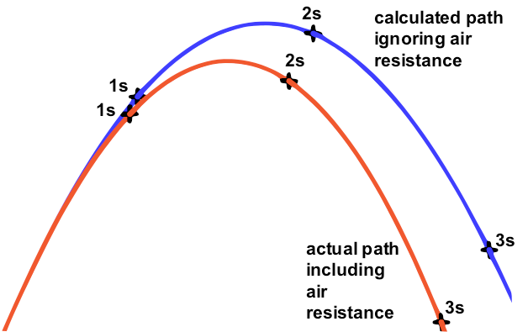

Select from the terms ***increased*** OR ***decreased*** OR ***had no effect on*** to correctly complete each of the following statements. (NB. You may use each term more than once.)

Air resistance _______________________________ the range of the ball’s flight.

Air resistance _______________________________ the height of the ball’s flight.

Air resistance _______________________________ the time of the ball’s flight.

**Question 7 (4 marks)**

Satellites orbit freely around the Earth. They are sometimes placed in equatorial orbits (diagram A) and sometimes in polar orbits (diagram B).

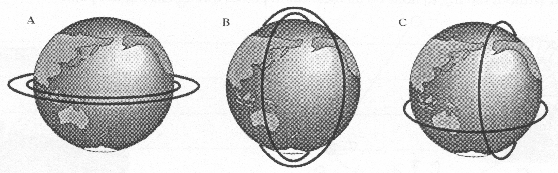

What different functions could satellites in ***Equatorial*** or ***polar*** orbits perform?

(i) Satellites in Equatorial orbits could:

(ii) Satellites in polar orbits could:

Why would it be impossible for satellites to orbit as in diagram C? (Use a diagram in your explanation.)

**Question 8 (4 marks)**

A beam of **-ve** electrons is directed towards the centre of a screen with four quadrants A, B, C, and D. When electric and magnetic fields are arranged as shown below, the electron beam is deflected.

|  |  |
| --- | --- |
|  | Which quadrant of the screen is the beam most likely to strike? ________________  Explain your answer. |

**Question 9 (5 marks)**

*The following problem describes one of the many theories that attempt to explain how ancient Egyptians, using manpower alone, were able to raise heavy stone blocks in building pyramids. According to this theory the blocks, lubricated with mud, were pulled up a ramp by a team of men*.

A stone block of mass 5.0 tonne is pulled up a ramp inclined at 10.0 degrees to the horizontal by a team of men pulling on a rope. The force of friction between the block and the ramp is 10 000 N.

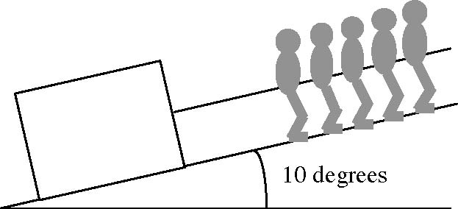

1. (a) On the diagram show the main forces acting on the block. (2 marks)
   * + 1. (b) Determine the vector component of the *weight* of the block acting parallel to the ramp, and hence show that the *minimum* force needed to make the block slide up the ramp is 18 500 N. (3 marks)

**Question 10 (4 marks)**

|  |  |
| --- | --- |
| Two ropes support a non-uniform palm tree.  (a) What is the mass of the palm tree? |  |
| (b) Indicate the position of the palm tree’s centre of mass on the diagram. | |

**Question 11 (4 marks)**

**Estimate** the **minimum speed** required for a bucket of water to be whirled in a vertical circle so that the water does not fall from the bucket. (Be sure to include any assumptions in your answer.)

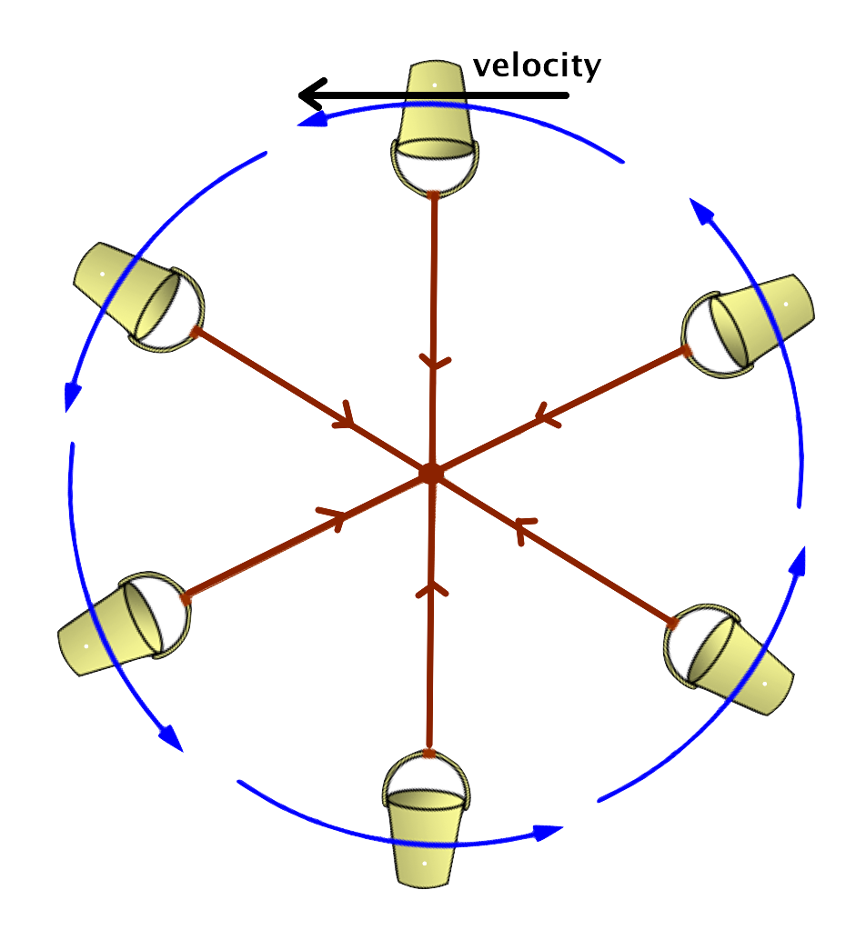

**Question 12 (4 marks)**

Mr Meagher has a mass of **80.0kg** on the surface of Earth. What would he weigh on the surface of Mars, if Mars has a mass that is **0.107 times that of Earth**, and a radius that is **0.529 times that of the Earth**?

**Question 13 (3 marks)**

During a lunar eclipse the Sun, Earth and Moon are aligned as indicated in the diagram below. Will the gravitational attraction between the Earth and the Sun be larger, the same or smaller than during a solar eclipse? (NOTE: The diagrams below are not to scale in regards to sizes and distances.)

___________________________

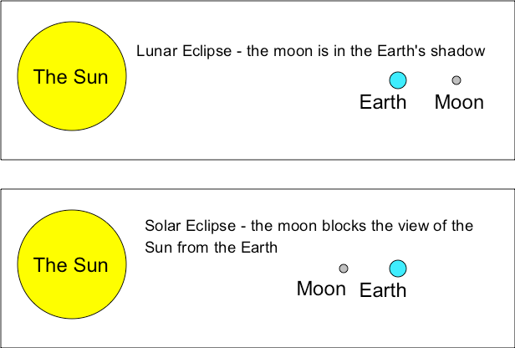

Explain your answer.

**End of Section One**

**Section Two: Extended answe**r **50% (90 Marks)**

This section has **seven (7)** questions. You must answer **all** questions. Write your answers in the spaces provided.

Suggested working time: 90 minutes.

**Question 14 (7 marks)**

An amateur astronomer decided to find the mass of the planet Jupiter by measuring the periods and orbital radii of the of Jupiter’s four brightest moons (Io, Europa, Ganymede and Callisto). Using a small telescope she measured, over a few weeks:

* the greatest angle of separation of each of the moons from Jupiter (see diagram).
* the time taken for each of the moons to return to the same position in its orbit.

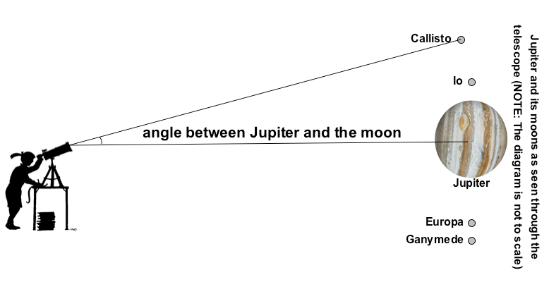

(a) What further information is needed to allow the astronomer to determine the *distance* (ie orbital radii) of each moon from Jupiter? (1 mark)

After converting her angular measurements to orbital radii, the astronomer obtained the following graph (of T2 (x1012s2) against R3 (x1027m3)) summarising her data:

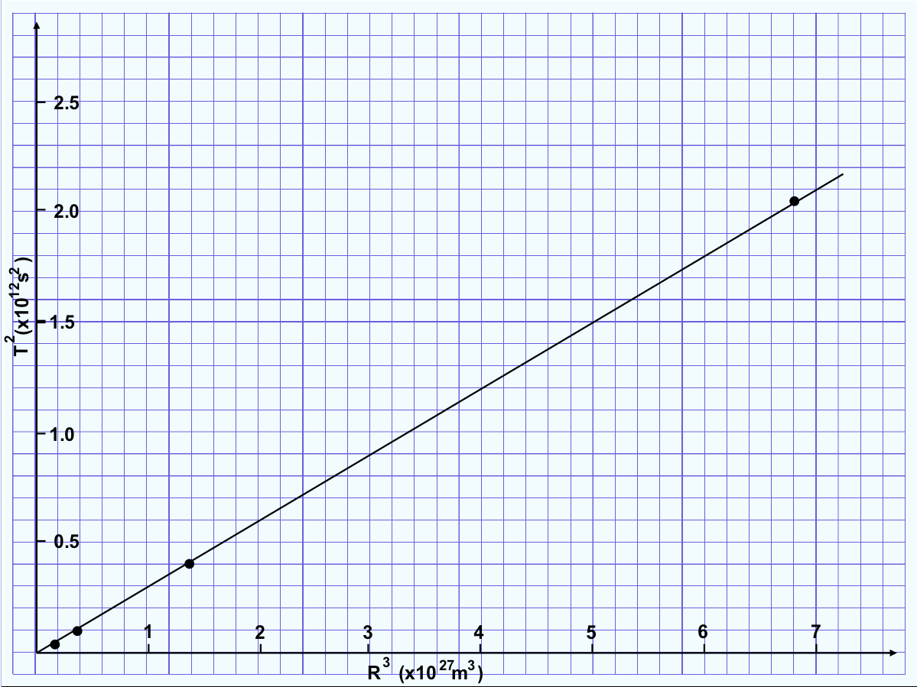

(i) Calculate the gradient of the graph. (2 marks)

(ii) What value for the mass of Jupiter can be obtained from this graph? (4 marks)

**Question 15 (21 marks)**

*NASA has encouraged future human exploration of the planet Mars.*

*Because this is a long journey, it will require the development of some means of preventing high-energy particle radiation (such as protons emitted by the sun and heavier charged nuclei from interstellar space) from penetrating the spacecraft. Some possible techniques are discussed in the next questions.*

Astronauts travelling to Mars will be subject to dangerous radiation consisting largely of positive ions. One technique that has been proposed for deflecting this radiation away from the spacecraft is to give the spacecraft a high positive charge.

Ions of iron approaching the spacecraft have the following properties:

mass = 9.35 × 10-26 kg  
charge = + 1.6 × 10-19 C  
kinetic energy = 500 MeV (ie 8 x 10-11J)

(a) Show that the speed of these ions is 4.14 × 107 ms-1. (2 marks)

(b) What should be the potential difference between the spacecraft and the surrounding space if it is to successfully deflect these 500 MeV (ie 8 x 10-11J) ions? (2 mark)

(c) Given that electrons are also present in space, what would be one of the problems associated with this technique? Would this proposed simple arrangement give the astronauts any real protection? (2 marks)

(d) Suppose the ions were to enter a uniform electric field of strength E = 5.0 x 108 Vm-1. The ions are travelling perpendicular to the field, as ions shown in the diagram.

1. Show that the acceleration of the ions inside the electric field is 8.56 × 1014 ms-2. (2 marks)

(mass = 9.35 × 10-26 kg and charge = +1.6 × 10-19 C)

1. Through what distance *parallel to the field* will each ion have been deflected after it has travelled a distance of 1.0 m *perpendicular to the field*? (4 marks)

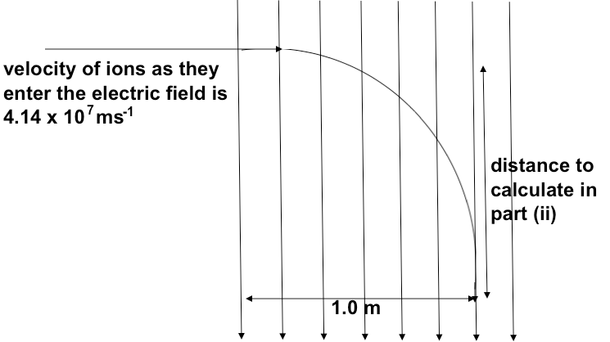

Another suggestion to protect the astronauts is to have an electromagnet encircle the living quarters of a space-craft journeying to Mars. This would produce a magnetic field, as shown in the next diagram. The diagram below shows a ‘top’ view of this arrangement together with the initial paths of two charged particles (positive and negative) approaching the living quarters.

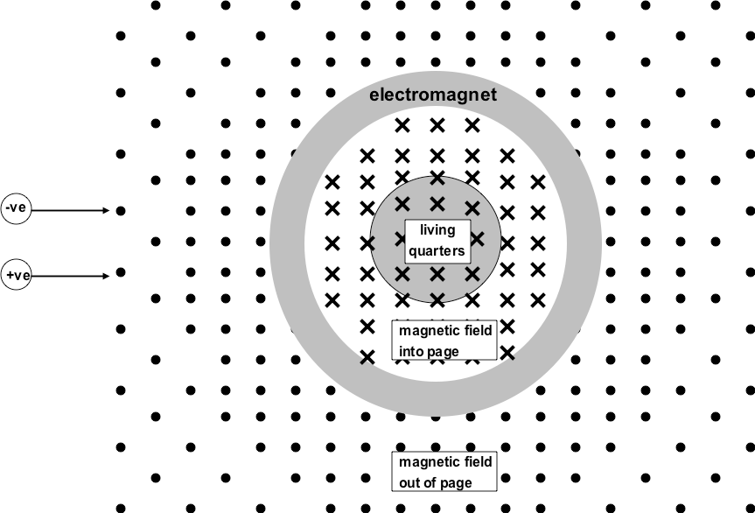

(e) Draw arrows on the above diagram to show:

* + - The direction of the magnetic force on each of the two charged particles. (2 marks)

(f) The next diagram shows a side view of the above arrangement. Show on the diagram the paths of positive or negative particles that ***would*** be able to reach the living quarters ***without*** deflection. (1 mark)

1. 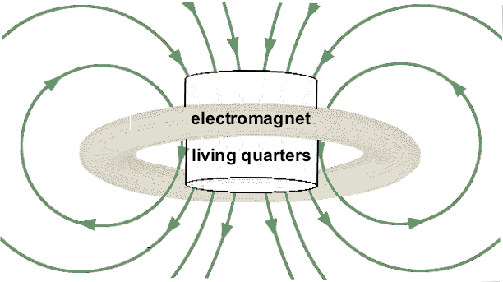

(g) If ions approaching the magnetic field have a speed 4.14 x 107 ms-1, a charge of +1.6 x 10-19 C and a mass of 9.35 x 10-26 kg. Determine the magnetic field intensity required to deflect these ions into a circular path of radius 5.0 m. (3 marks)

(h) Magnetic fields of less than 5.0 T do not have any obvious effect on people who are stationary, but when people *move* in such fields they experience unpleasant effects (such as dizziness and eye flashes) which suggest that the fields are having an effect on the brain. Why might *movement* in the field have such consequences? Illustrate your answer with a suitable calculation, assuming that the speed of movement is 0.5ms-1 and the most common positive ion in the brain (Na1+) has a charge of +1.6 x 10-19C, and a mass of 3.82 x 10-26kg. (3 marks)

**Question 16 (26 marks)**

The next set of questions refer to objects in and around an airport

The Aircraft

An aircraft is flying at a ***constant height*** of 600 m above the ground.

(a) Explain why the aircraft flying is **not** an example of projectile motion. (2 marks)

(b) While the aircraft is flying **horizontally** at a speed of 50 m s–1, a packet is dropped from it.

Calculate the **speed** of the packet when it reaches the ground (include a vector diagram).

(4 marks)

|  |  |
| --- | --- |
|  | *diagram* |

(c) The aircraft has a ***constant*** horizontal airspeed of 50 m s–1.

The pilot wants to fly directly east, but there is a wind blowing **from the north** with aspeed of

40 m s–1.

Draw a **labelled** scale vector diagram showing the direction in which the pilot must **point** the aircraft.

Use the diagram to calculate the angle between the aircraft and north (the bearing). (3 marks)

|  |  |  |
| --- | --- | --- |
|  |  |  |
|  | *labelled scale vector diagram* | compass |

(d) While landing, the speed of the aircraft reduces from 50.0 m s–1 to 20.0 m s–1 in 8.00 seconds.

Calculate the **magnitude** and **direction** of the acceleration. Express your answer to the **correct number** of **significant figures**. (3 marks)

At the airport

Some painters are working at the airport. They have a uniform plank resting on two supports. The plank is 4.0 m long. It has a mass of 22 kg. The two legs that support the plank are 0.50 m from either end, as shown in the figure below.

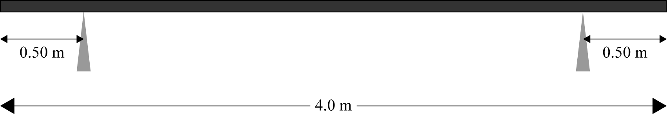

(e) The plank is in equilibrium.

Draw labelled arrows of **appropriate sizes** and **in the correct positions,** showing the **forces** acting **on** the **plank** on the diagram above. (3 marks)

(f) Calculate the support force on the plank at A if a painter of mass 60 kg sits 0.75 m from A, and another painter of mass 75 kg sits at a distance of 0.80 m from B.

Use *g* = 9.8ms–2. (5 marks)

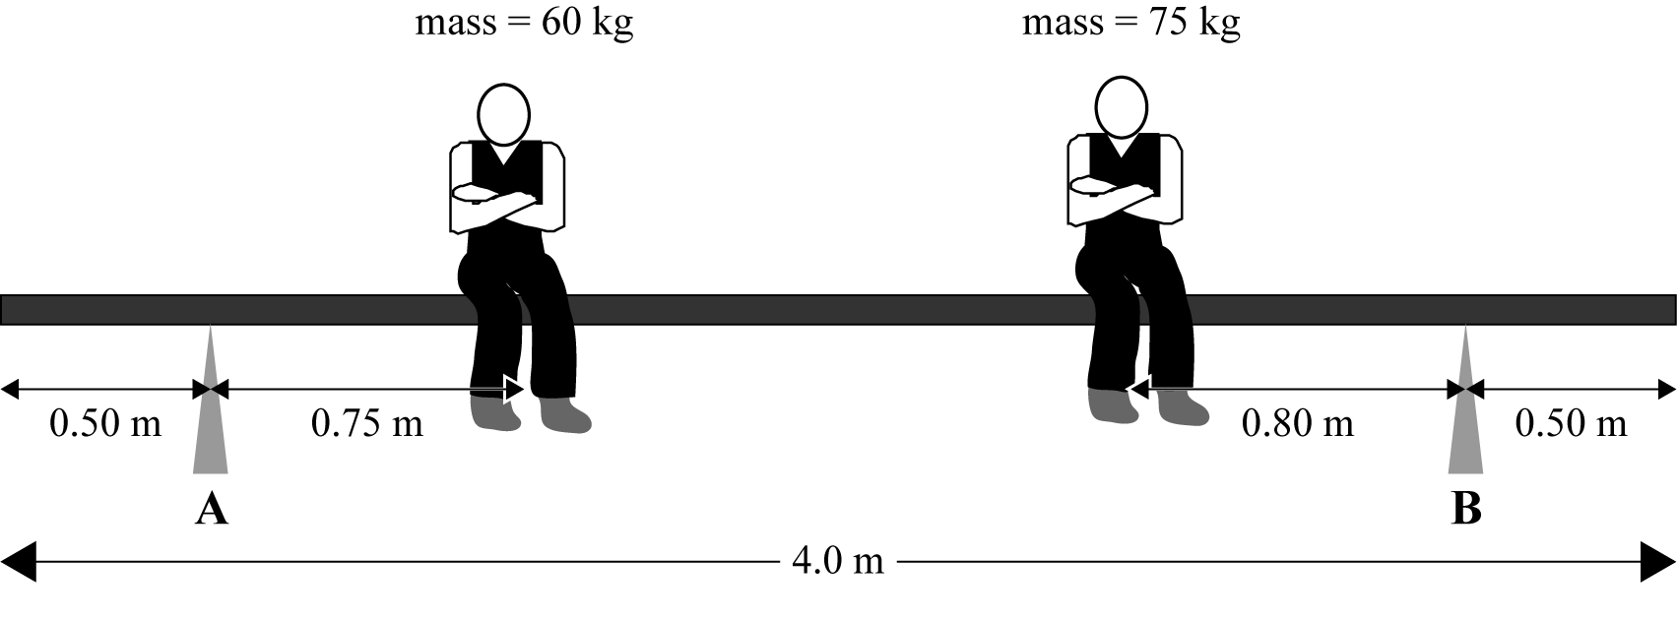

The baggage section

The baggage at the airport is delivered on a horizontal circular conveyor belt that is moving at constant speed. The radius of the circular belt is 7.0 m.

(g) Draw an **arrow** on the diagram below to show **the direction** of the velocity of the suitcase that is on the moving circular belt. (1 mark)

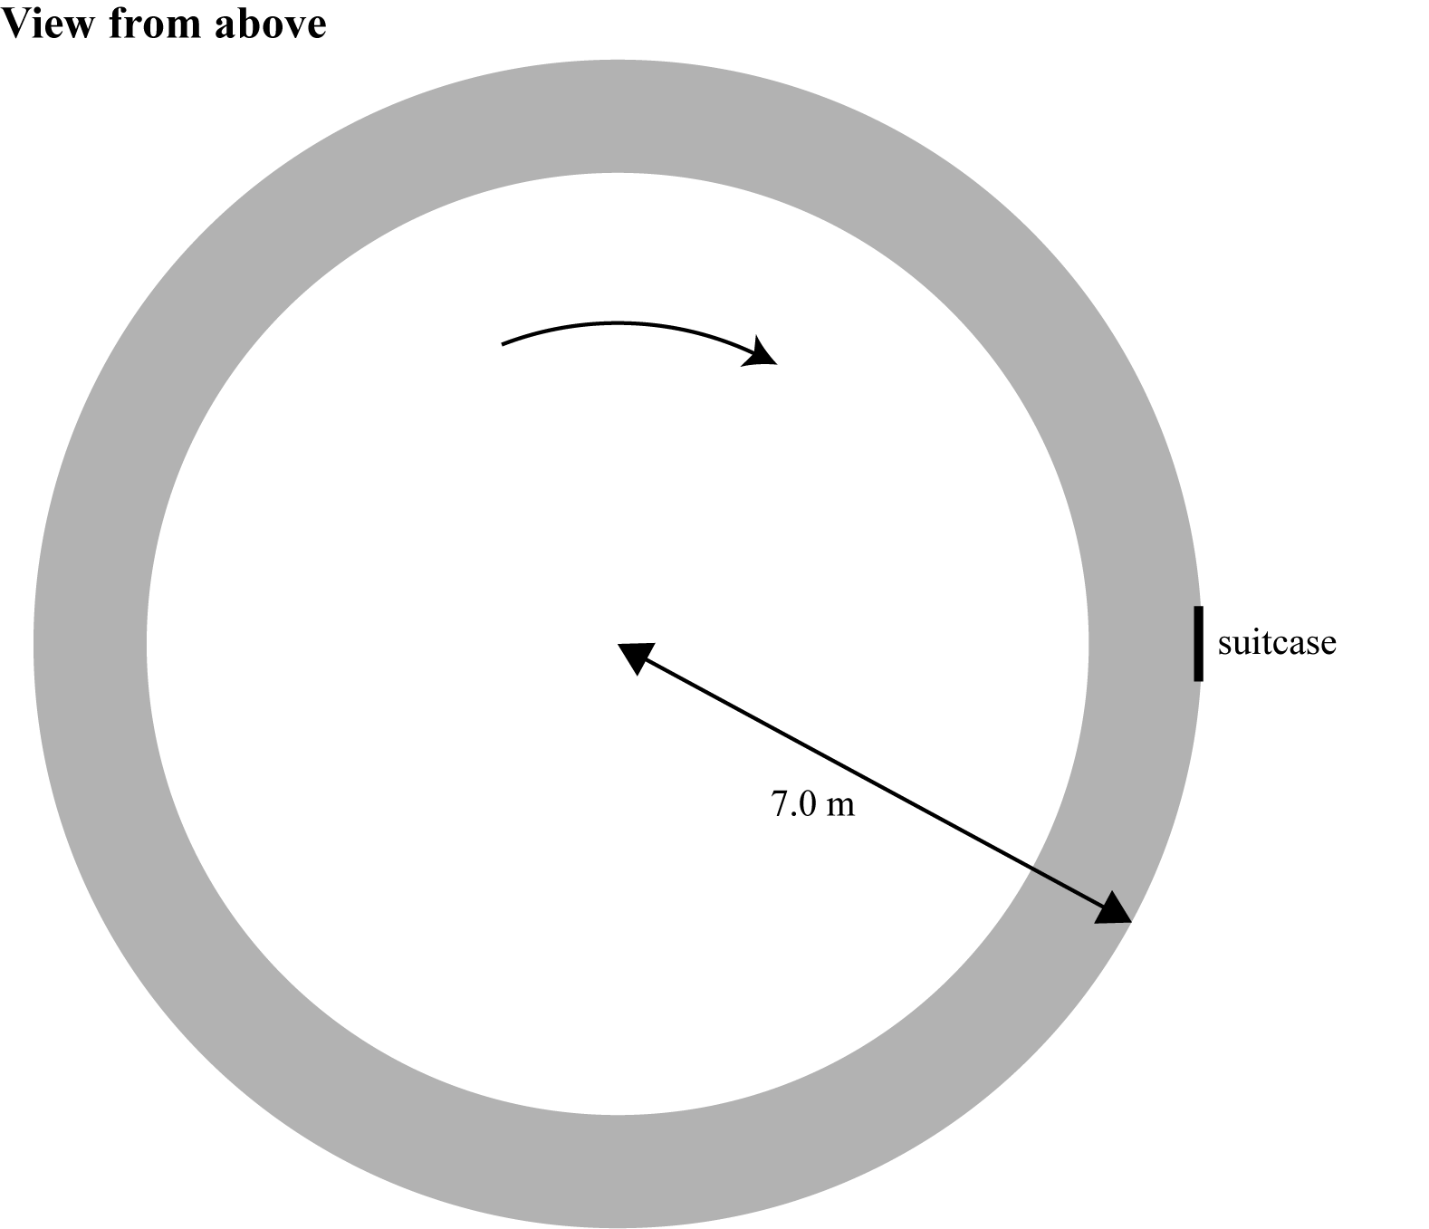

(h) Explain why the motion of the suitcase on the belt that is moving in a circle at constant speed is accelerated motion. (2 marks)

(i) Calculate the time it takes for the belt to complete one rotation if the **unbalanced force** on the suitcase is 5.5 N. The mass of the suitcase is 18 kg. (3 marks)

**Question 17 (13 marks)**

|  |  |
| --- | --- |
| Boom microphone stands are used in professional recording studios. The diagram at right shows one such stand. It consists of a uniform 1.80m and 850g boom pivoted at an adjustable hinge 1.20m from the end that holds the microphone. At the other end of the boom and 0.60m from the hinge is a counterweight. The boom is in equilibrium at an angle of 500 to the vertical.  (a) What two conditions must have been satisfied for the boom to be in equilibrium?  (2 marks) |  |

(b) What must be the counterweight ‘s mass at the end of the boom opposite to the microphone for this equilibrium to have been established? (5 marks)

(c) What force must exist at the hinge? (Note: If you did not get an answer for part (b) then use 1.10kg as the mass of the counterweight.) (2 marks)

(d) (i) Draw a diagram of the boom, when adjusted so that it is horizontal to the floor.

(ii) Determine, with a calculation, if it will still be in equilibrium when adjusted like this. (4 marks)

**Question 18 (8 marks)**

*Pulsars are rapidly spinning astronomical objects. When they were first discovered, astronomers were not sure what they were. Two possibilities were:*

• ***white dwarf*** *stars, which typically have a mass similar to the sun’s mass and a radius similar to that of the Earth;*

• ***neutron stars****, which have a mass similar to the sun’s mass and a radius of less than 20 km.*

A ‘star’ of mass of about **2.8 x1030 kg** is observed to be rotating with a frequency of**30 Hz** (ie it completes 30 revolutions every second!).

When answering this question, you are attempting to determine what type of star it is mostlikely to be.

(a) If this ‘star’ is a ‘white dwarf’, it would have a radius of approximately **7.0 x106m**. Show that theacceleration due to gravity at the surface of this white dwarf would be approximately**3.8 x106 ms-2**. (3 marks)

(b) Show that the centripetal acceleration of a point on the equator of this star, that rotates at 30Hz, would be **2.5 x 1011 ms-2**. (3 marks)

(c) Comparing the answers to (a) and (b) above, would it be possible for the star to be a white dwarf? Give reasons for your answer. (2 marks)

**Question 19 (15 marks)**

A rock in a sling is swung in a vertical circle with a constant speed of 5.00ms-1 and released at the bottom of the circle. It then travels forward as a projectile while falling 2.00m to the ground.

|  |  |
| --- | --- |
| Mac HD:Users:localadmin:Desktop:Screen Shot 2012-04-18 at 10.29.31 AM.png |  |

(a) What tension will the sling exert on the rock at the point T (ie at the top of the swing)? (2 marks)

(b) What is the mass of the rock? (3 marks)

(c) Which of the three vectors (i), (ii) or (iii) indicates the direction of the velocity of the rock as it leaves the sling at B? (2 mark)

(d) What will be the range of the rock (ie how far does the rock travel horizontally between leaving the sling and striking the ground)? (4 marks)

(e) What will be the magnitude and direction of the rock’s velocity as it strikes the ground? (4 marks)

**End of Section Two**

**Section Three: Comprehension and data analysis**. **20% (36 Marks)**

This section contains **two (2)** questions. You must answer both questions. Write your answers in the spaces provided.

Spare pages are included at the end of this booklet. They can be used for planning your responses and/or as additional space if required to continue an answer.

• Planning: If you use the spare pages for planning, indicate this clearly at the top of the page.

• Continuing an answer: If you need to use the space to continue an answer, indicate in the original answer space where the answer is continued, i.e. give the page number. Fill in the number of the question(s) that you are continuing to answer at the top of the page.

**Question 20 (18 marks)**

A student conducted the following experiment and collected data (which is recorded in the following tables). Process their results to answer the questions (a) to (g).

**Experiment: Measuring the mass of the Earth**

**Aim**

To measure the mass of the earth using a conical pendulum

**Background information**

For a conical pendulum, the centripetal force (which causes the pendulum bob to go around in a circle) is equal to the horizontal component of the tension in the string and the weight is equal to the vertical component of the tension.

|  |  |  |
| --- | --- | --- |
| **Equipment needed**   * A small mass of between 200g – 300g * String, 600mm long*.* * Rule * A sheet of A3 paper with a circle drawn on it * Stopwatch * A paper clip | Screen shot 2011-04-22 at 9 | From this you could work out that  g =  Using this value of g in the relationship below  gE =  and knowing the earth’s radius, you can calculate  the mass of the earth. (G = 6.67 x 10-11 N m2 kg-2) |

**Procedure**

1. The diameter of the circle that is drawn on the A3 paper was accurately measured as **0.285m**.

2. Masses were tied onto the string and the string was attached to the paper clip, so that the length of the pendulum was between 200 mm and 500 mm. These lengths were measured accurately and recorded. The paper clip was suspended at a fixed position over the centre of the circle on the A3 paper, and the pendulum was swung so that the centre of mass of the pendulum followed the circumference as closely as possible. The time taken for **20 complete revolutions** was measured. This was repeated another 2 times, and then repeated again for 5 different lengths.

**Experimental results**

|  |  |  |  |  |  |  |  |  |  |  |
| --- | --- | --- | --- | --- | --- | --- | --- | --- | --- | --- |
| Length  (mm) | Time 1 (s) | Time 2 (s) | Time 3 (s) | Average time (s) | Period ie T (s) | 2*π*r  (m) | Velocity  (ms-1) | v2  (m2s-2) | θ | tan θ |
| 200 | 15.1 | 15.2 | 14.8 | **15.03** |  | 0.895 |  | 1.42 | 45.4 | 1.015 |
| 250 | 18.4 | 18.2 | 18.0 | **18.20** |  | 0.895 |  | 0.97 | 34.8 | 0.694 |
| 300 | 20.5 | 20.8 | 20.4 | **20.57** |  | 0.895 |  | 0.76 | 28.4 | 0.540 |
| 350 | 22.9 | 22.6 | 23.0 | **22.83** |  | 0.895 |  | 0.61 | 24.0 | 0.446 |
| 400 | 24.7 | 24.3 | 24.4 | **24.47** |  | 0.895 |  | 0.54 | 20.9 | 0.381 |
| 450 | 26.3 | 26.5 | 26.2 | **26.33** |  | 0.895 |  | 0.46 | 18.5 | 0.334 |
| 500 | 28.2 | 27.6 | 27.7 | **27.83** |  | 0.895 |  | 0.41 | 16.6 | 0.297 |

**Processing of the results**

(a). Complete the data table. (2 marks)

(b). Plot a graph of v2 (vertical axis) versus tan θ (horizontal). (4 marks)



(c). Calculate the gradient of your straight line. (2 marks)

(d). Use the gradient from your graph to calculate g, the acceleration due to gravity. (2 marks)

(e). Using values of 6.37 x 106 m for the radius of the Earth (rE) and the value of g calculated in (d) determine the mass of the Earth. (NOTE: If you did not calculate a value for g in (d) then use 8.8ms-2.) (4 marks)

(f). The generally accepted value for the mass of the Earth is 5.98 x 1024 kg. Calculate the percentage difference between the value that you have calculated and the accepted value.

(2 marks)

(g). How could the accuracy of the experiment be improved? (2 marks)

**Question 21 (18 marks)**

The Earth's Magnetic Field

The Earth has a substantial magnetic field, a fact of some historical importance because of the role of the magnetic compass in exploration of the planet.

Structure of the Field

The field lines defining the structure of the magnetic field are similar to those of a simple bar magnet, as illustrated in the following figure.

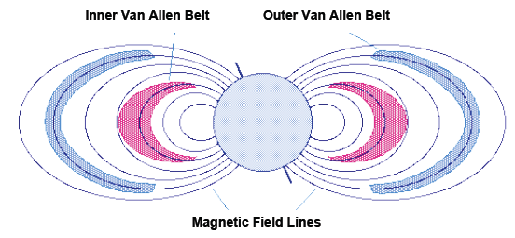

*Figure 1: The Earth's magnetic field and Van Allen radiation belts*

|  |  |
| --- | --- |
| **Paragraph 1**  It is well known that the axis of the magnetic field is tipped with respect to the rotation axis of the Earth. Thus, true north (defined by the direction to the north rotational pole) does not coincide with magnetic north (defined by the direction to the north magnetic pole) and compass directions must be corrected by fixed amounts at given points on the surface of the Earth to yield true directions. | Mac HD:Users:localadmin:Desktop:Screen Shot 2012-04-18 at 5.10.02 PM.png |

Van Allen Radiation Belts

**Paragraph 2**

A fundamental property of magnetic fields is that they exert forces on moving electrical charges. Thus, a magnetic field can trap charged particles such as electrons and protons as they are forced to execute a spiralling motion back and forth along the field lines. As illustrated in the figure above, the charged particles are reflected at "mirror points" where the field lines come close together and the spirals tighten. One of the first fruits of early space exploration was the discovery in the late 1950s that two regions with particularly high concentrations of charged particles, called the Van Allen radiation belts, surround the Earth.

**Paragraph 3**

The inner and outer Van Allen belts are illustrated in the top figure. The primary source of these charged particles is the stream of particles emanating from the Sun that we call the solar wind. As we shall see in a subsequent section, the charged particles trapped in the Earth's magnetic field are responsible for the aurora (Northern and Southern Lights).

Origin of the Magnetic Field

**Paragraph 4**

The motion of electrical charges produces magnetic fields. For example, the magnetic field of a bar magnet results from the motion of negatively charged electrons in the magnet. The origin of the Earth's magnetic field is not completely understood, but is thought to be associated with electrical currents produced by the coupling of convective effects and rotation in the spinning liquid metallic outer core of iron and nickel. This mechanism is termed the dynamo effect. Rocks that are formed from the molten state contain indicators of the magnetic field at the time of their solidification. The study of such "magnetic fossils" indicates that the Earth's magnetic field reverses itself every million years or so (the north and south magnetic poles switch). This is but one detail of the magnetic field that is not well understood.

The Earth's Magnetosphere

**Paragraph 5**

|  |  |
| --- | --- |
| The solar wind mentioned above is a stream of ionized gases that blows outward from the Sun at about 400 kms-1 and that varies in intensity with the amount of surface activity on the Sun. The Earth's magnetic field shields it from |  |

much of the solar wind. When the solar wind encounters Earth's magnetic field it is deflected like water around the bow of a ship, as illustrated in the image above.

**Paragraph 6**

The imaginary surface at which the solar wind is first deflected is called the bow shock. The corresponding region of space sitting behind the bow shock and surrounding the Earth is termed the magnetosphere; it represents a region of space dominated by the Earth's magnetic field in the sense that it largely prevents the solar wind from entering. However, some high-energy charged particles from the solar wind leak into the magnetosphere and are the source of the charged particles trapped in the Van Allen belts.

Questions:

a. What is the difference between True North and Magnetic North. (***paragraph 1***).

[2 marks]

b. How does the Earth’s magnetic field trap charged particle from the Sun to form the Van Allen Belts? (***paragraph 2***)

[3 marks]

c. The Aurora (***paragraph 3***) can be seen from Polar Regions. Briefly how charged particles from the Sun are able to penetrate the Earth’s atmosphere when entering near the North and South Poles.

[2 marks]

d. How is the magnetic field of a bar magnet generated? (***paragraph 4***).

[2 marks]

e. What evidence is there that the magnetic poles of the Earth have switched every few million years? (***paragraph 4***).

[2 marks]

f. The Earth’s magnetic field shields the Earth from solar wind (***paragraph 5***). If the

Earth’s axis was rotated 90° so that the South Pole faced towards the Sun, would this influence the effectiveness of the shielding effect? Explain.

[3 marks]

g. An alpha particle (ie helium nucleus ) moving at a speed of 2.00 x 102 m s-1 away from the Sun, is deflected by the Earth’s magnetic field, so that its radius of curvature is 2.00 x 108 m. If the alpha particle has a mass of 6.65 x 10-27 kg and a charge of 3.20 x 10-19 C, find the intensity of the Earth’s magnetic field at that point.

[4 marks]

**End of questions**